Wallpaper
Not just a wall in Grandma’s house anymore.
Wallpaper is making (or has made) a come-back and in a huge way. You probably recall Grandma’s house had that room that was plastered from roof to floor with a gory floral declatage? Does this photo from Google images help you to recall?
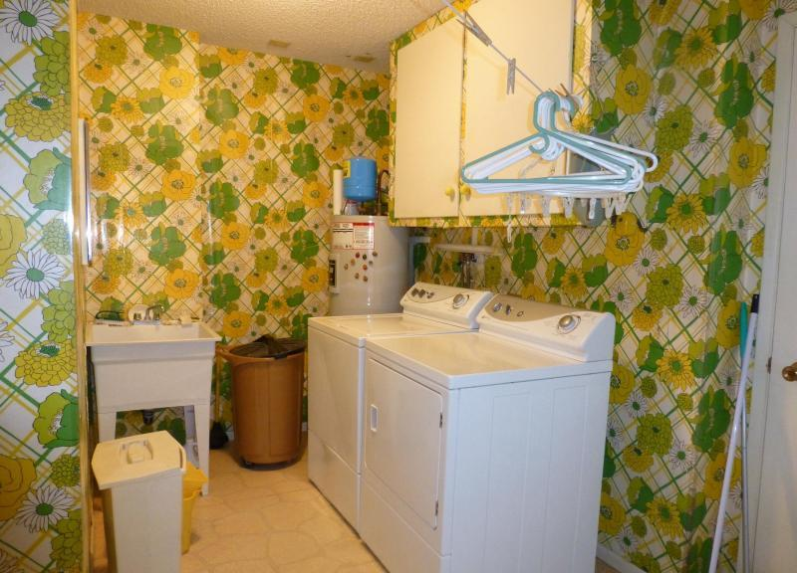
We are happy to say that this is no longer the case and some of the wallpaper jobs we have been doing lately are definately a far cry from gory.
At Darren Slater Painter & Decorator, we can apply your wallpaper to your home or office with minimum down time. Long gone the days of messy, unmanageable glues. These modern wallpapers have helped make the application much easier for professionals.
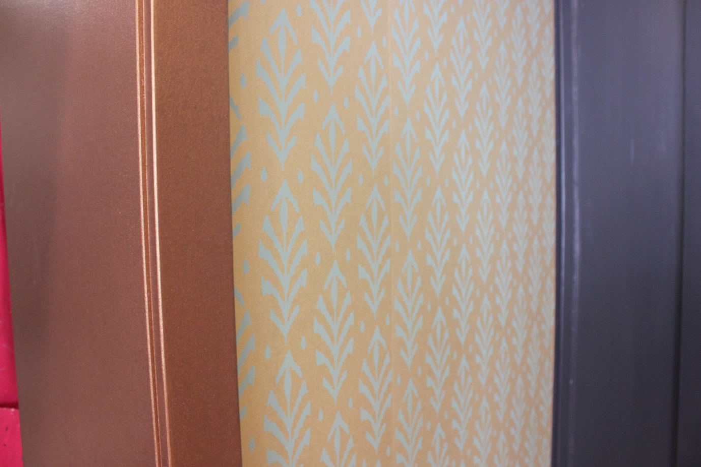
From elegance to art deco, the commercial application of all these wallpapers will stand the test of time. Not only are they eye catching, they are durable, strong and easy to clean.
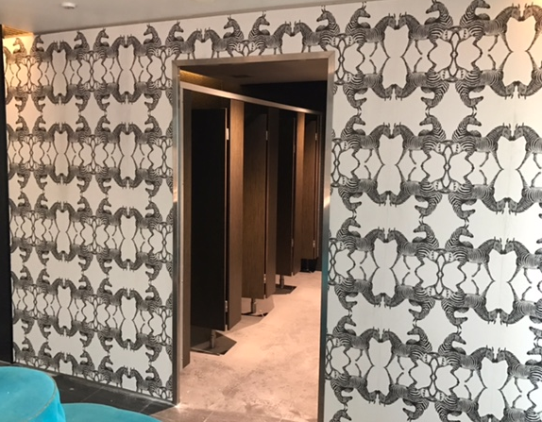
So when you are looking for that something different, don’t be afraid to think wallpaper.
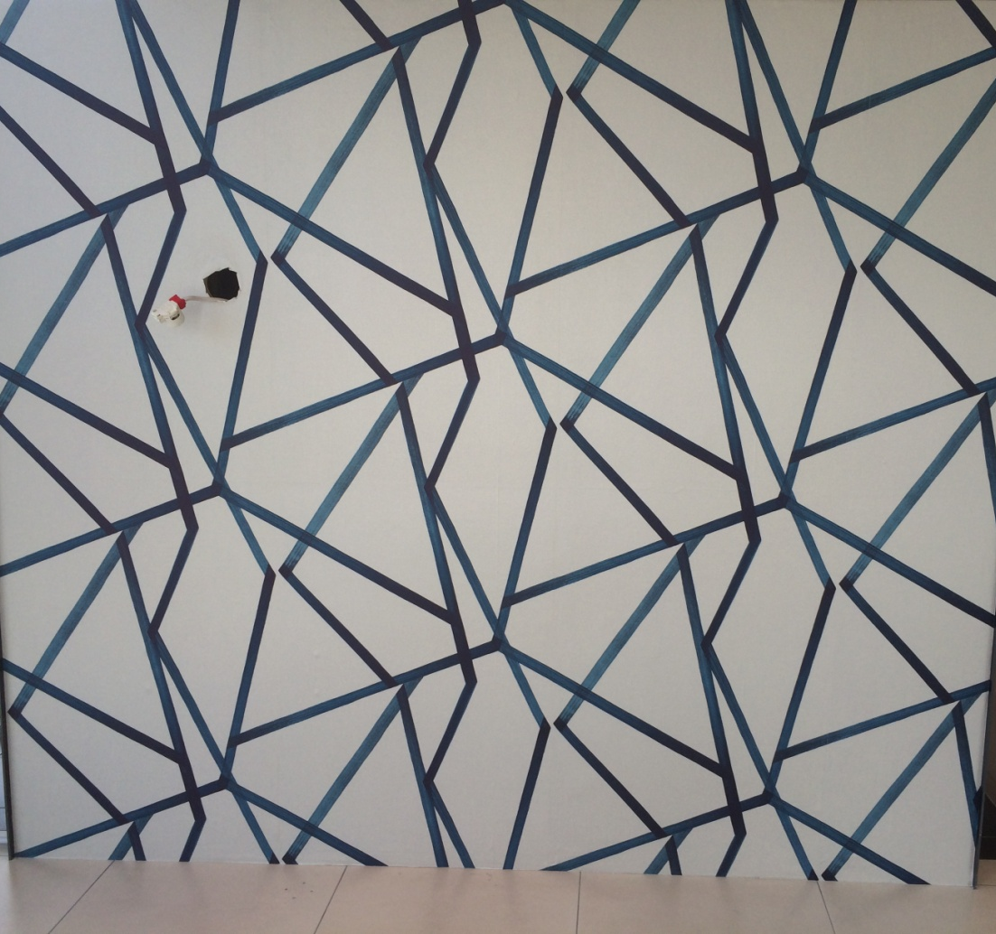
Now doesn’t this make a statement!
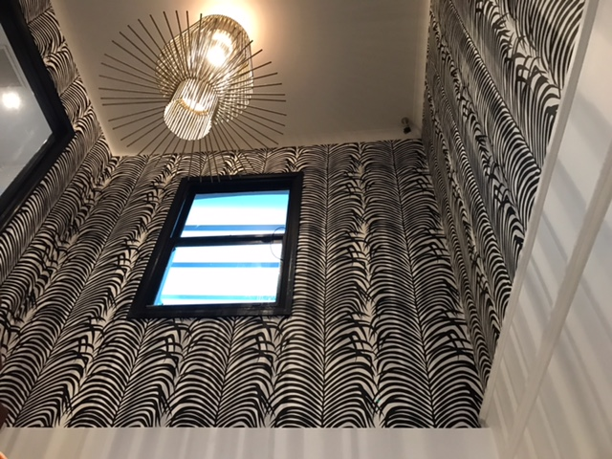
So let out your inner designer and see what results you can achieve. Give Darren a call to discuss your ideas.

